Prompting overview: Fulton Browne
5. A final reflection document
Each team member writes one page describing:
• How they wrote prompts
• How they validated AI output
• What they learned about spec-driven development
• What they would change next time

When building applications of any scale strict prompting is very important. Specifying strict requirements around technologies, methods, and best practices is always important and that is very proven in the human readability and understanding of the code. The biggest issues we can't get into wasn't around code output itself but around understanding of external apis, luckily tools like context7 can alleviate this however it wasn't initially prompted to use it therefore initially using bad API calls, after prompting it to research it took advantage. Spec driven development may reduce error rates on certain project fronts but upon redoing the application with its methodologies I found it to be over compartmentalized and did a very poor job of architecting the platform as a whole rather creating over fragmented code that relied on many network requests. While the larger plan then implementation model has downsides around large amounts of code output being buggy the code tends to have better architecture and a better fully integrated system that can then be refactored more easily later if need be (and if it relies on good principles the system may be sound). Next time I would lean away from spec driven and move more towards plan driven while also more explicitly prompting in docs and web research tools to avoid the initial issues around the APIs.

DYLAN SPIVEY:
I mostly took the prompts the team wrote, ran them through Claude Opus 4.7, and ran whatever code came back. This made me the first to notice when something compiled cleanly but didn’t actually work. I passed initial prompts through as-is, but some of follow-ups were mine when the output didn’t come back the way we wanted. Then, I’d write a more specific version of the previous prompt that named the exact thing to fix. The most common failure was the AI picking the wrong-shape call to a real endpoint and getting back empty results. Sometimes the city search hit the Census onelineaddress endpoint, which only matches full street addresses. So you would get issues like where “Boston, MA” wouldn’t return anything until I tried it in the browser. I validated output by running the dev server and clicking through the feature, since type checks and a passing build said nothing about whether the right data came back. I do have to agree with Fulton that spec-driven hurt us a little. It seemed like each prompt produced a self-contained piece that didn’t know about the others. This is how we ended up calling NWS /points twice for the same coordinates. Personally next time, I’d tighten the prompts, then run the code and report it to the team so they can catch failures the same minute they appear.

ISAAC HENNESSEY:

Before writing each prompt I thought through the scope of what I wanted to accomplish and tried to break down the prompt into bite sized pieces to understand what was going on. At first we prompted at a much larger scale than intended, which caused us to have to redo our project. We validated AI output by having Claude restate the prompt we gave it. We learned that spec driven development is itself a structure to follow when building an application as a team similar but slower than plan or agile development. If I could change anything next time, I would make sure to have the AI write out the requirements back to us the first time so that we know exactly how the agent will run when actually executing. For automated testing we used Vitest, by first creating tests to verify that what the user searches for appears in the URL for actually calling the API. Then we defined tests for making sure the API calls for the right place when searching by name. Vite verifies the functionality by confirming that the expected coordinates match the searched ones.

Response to how does tanstack query work

Results can be unpredictable and AI can have a hard time understanding certain outputs and what certain things need to look like so AI needs to have hard guidelines. AI is good at writing tests

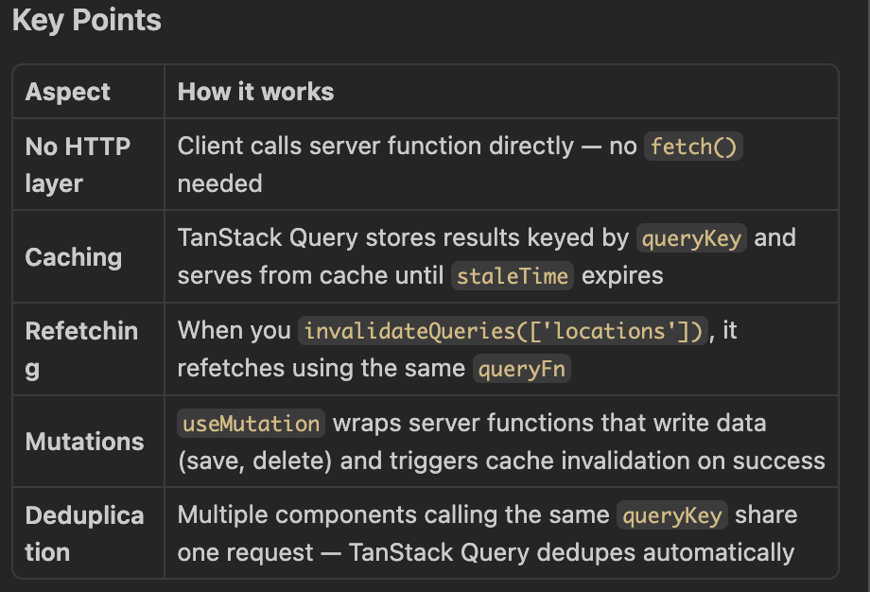

How does vitest work?

